Your Business
Plan Template

YOUR COMPANY NAME / BRAND HEADER

CONTACT
CONTACT | DIRECT DIAL PHONE NUMBER: |  | postal address:
CONTACT | Mobile Phone Number:
CONTACT | Email Address:
CONTACT |  |  | Physical address:

ONLINE:
ONLINE: | website: |  | Google+:
ONLINE: | linked in: |  | Blog URL:
ONLINE: | facebook: |  | YouTube / Vimeo:
ONLINE: | Twitter

Business
business overview

History
The background to the business to date:
Keep the history of your business brief; it will be of limited interest unless it helps to explain the current position of the business.
objectives  What we plan to achieve  in the short term and  long term: | Next one to two years:
 | next three to five years:

products or
Services
What we are offering customers:
Ask a friend who knows nothing about the business to read this section. If the friend can’t gain a clear idea of what you intend to do, rework your description.

generating
Money
An explanation of our business model (how the business will make money):
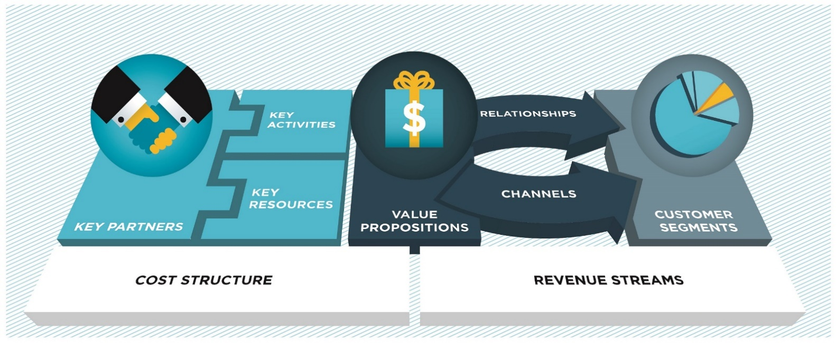
our key activities
Overview of your main activities.

Revenue
Streams
Products and services that will generate revenue.

Our key partners
Suppliers, subcontractors and other partners who help us produce and market our products and services.

key resources
Resources critical to your success.

MArket Niche
The market niche we have identified:

Core CompetitivE Advantage
Our core competitive advantages – what we offer customers that our competitors don’t:
Explain why your value proposition(s) will give your business a durable advantage.

Getting to customers
Distribution channels we will use to reach our market:
For example, shop, website, agents or distributors, wholesalers and retailers. Show that you will avoid channel conflicts, such as undercutting retailers with lower website pricing.

compliance issues
Compliance issues we have identified and how we have solved them or plan to solve them:
For example, licences, permits, health and safety requirements and resource consents.

business structure
Our choice of business structure (for example, Sole Trader, Partnership, Limited Liability Company) and why we chose it:

Strategy
business goals  Our business goals (what do you want to achieve) in the short and long term:  Ensure your goals are specific and measurable. | Our goals for the next 12 months
Specific tactics and stepping stones to these goals. | How we plan to achieve these goals
Explain how you will measure success. | What success will look like
Ensure your goals are specific and measurable. | Goals for the next three to five years
Specific tactics and stepping stones to these goals. | How we plan to achieve these goals
Explain how you will measure success. | What success will look like

Key Competitor analysis  Our key competitors’  strengths and weaknesses,  and how we plan to complete  against them:  Cover your top three to five competitors. | competitor | Strengths | Weaknesses | Our response
 | 1:
 | 2:
 | 3:
 | 4:
 | 5:

swot analysis  analysis of  our Business  Include your advisors and  key staff in this exercise.  Refer to the lists in chapter two in the Planning for  Success Guide on SWOT analysis to ensure you’ve covered the essentials. |  | Strengths | Weaknesses
 | external factors
 | criteria  to consider | opportunities | threats

Core values
The core values that
underpin our business:
Condense your values
statement into one or two
short sentences at most.

Market

Customer and market profiles  Our customer types explained:  Be as specific as possible in your profiling. | market segment 1
 | market segment 2
 | Market segment 3

Validating demand
Our evidence of market demand:

Market size and sustainability  Our market research: | Market Size
If your business can be scaled, perhaps to overseas markets, then describe this extra potential, as it will be of particular interest to investors. | Market Sustainability
Note any threats that could affect market sustainability, such as changing technology, competitor reaction to your market entry, or economic downturns. Describe how you might cope with these threats. | Threats

Promotion plan
Our marketing strategy for the next 12 months:
☐Marketing budget timeline
attached.

Branding and IP protection  How we are protecting our brand and intellectual property from being copied or damaged: | Problem or conflict source | Solution

Skills, people and systems
Skills and experience
An outline of my skills, experience and qualifications:
If you lack business experience or qualifications then consider postponing your plans while you gain some experience by working in the industry you want to enter and taking some small business courses.

Well-balanced team
An outline of the skills, experience and qualifications of my key team members:

Advisers
The skills my advisory team bring to the table:

Business Support Networks
An outline of the support networks I have access to:

Business systems
Important systems we have adopted or are developing to enable us to deliver to customers:
For example, systems for accounting, budgets, tax and compliance issues, production and order fulfilment.

Customer service
How we plan to deliver excellence to customers:

Productivity and technology
The productivity software and technology we use, and how it benefits the business:

Technology advances
Areas of innovation we are monitoring:

Finance
Business feasibility
A summary of our break-even calculations and assessment of how feasible the business is:
If your business idea is simply not feasible then it’s better to find this out now than to plunge ahead and lose your capital. Your time has not been wasted; the knowledge will pay off next time.

Cash flow forecast
A summary of our cash flow forecast:
☐Cash flow forecast attached

Sustainable cash flow
How we plan to achieve predictable revenue streams in the business:

Product/service pricing
How we have priced our products/services:

Monitoring performance  The Key Performance Indicators we plan to use to monitor business performance: | FINANCIAL KPIs
 | marketing kpis
 | Specific KPIs that drive our business

Positioning strategy
How we plan to position our business in the marketplace:

Funding YOUR BUSINESS  How we will fund the business:  Include what checks you have taken – such as a review by your accountant or financial adviser −to avoid underestimating start-up costs. | start-up funding
 | post start-up growth

Summary
Keep this brief while covering these three critical topics: the viability of your business; any gaps you still need to close; and the main points of your plan.

Attachments
List the financial documents attached to your Business Plan.

